**Environmental Economics**

Academic Year 2024/2025

**The Role of Subsidies and Taxes in Promoting Green Technology**

**Wajid Ali Qureshi (0001122257)**

Alma Mater Studiorum - Università di Bologna

**Tony Segal**

University of California, Santa Barbara

**1. Introduction**

Climate change continues to be one of the most pressing issues of the 21st century, needing a transition toward sustainable economies through innovative technologies such as green energy solutions, electric vehicles, and other environmentally friendly technologies (Gilli et al., 2024). These green technologies are essential in reducing greenhouse gas emissions and reaching global climate stabilization goals (Barman et al., 2023). However, market forces alone are insufficient to drive the necessary changes, making green subsidies and carbon taxes vital for advancing clean energy adoption (Adão et al., 2024; Xu & Lin, 2024).

Economic theory supports the use of carbon taxes and subsidies to correct market distortions. Carbon taxes, based on Pigouvian theory (Pigou, 1920), internalize the social cost of emissions by raising the costs of carbon-intensive activities, thus promoting cleaner alternatives (Cannan, 1921; Pindyck, 2017). Canada exhibits a good example of a successful carbon tax, specifically the British Columbia’s 2008 tax, which is reducing emissions and promoting green technology (Kumbhakar et al., 2022). However, challenges like political resistance and carbon leakage remain (Nordhaus, 2007). Subsidies aim to reduce costs for green technology development, addressing underinvestment in R&D (Lu et al., 2024), exemplified by U.S. Production Tax Credit (Fischer, 2016). Nonetheless, subsidies can lead to resource misallocation and over-reliance (Fischer et al., 2017; Acemoglu et al., 2012).

This essay seeks to explore the importance of government policy, specifically a carbon tax and green subsidy programs, in reducing carbon emission that ultimately lead to promoting technology. The importance of government policy can be seen in Appendix 1. It shows how well-designed policies can significantly change emission trajectories. The novelty of this study lies in its comprehensive analysis of how carbon taxes as well as green subsidies can complement each other to overcome market failures and promote the adoption of green technologies.

**2. Carbon Tax and Economic Theories**

**2.1. Carbon Tax and Green Technologies**

Carbon pricing is a market-based instrument designed to reduce greenhouse gas emissions by imposing a financial cost on the carbon content of fossil fuels and is one of the primary strategies used to combat the growing issue of climate change (Cao et. al, 2009). By making carbon-intensive activities more expensive, it incentivizes firms and individuals to adopt cleaner technologies and reduce their carbon footprint. This tax mechanism, grounded in economic principles, seeks to internalize the social costs of carbon emissions, which are otherwise not reflected in market prices. Carbon taxes can be implemented at various stages of production and consumption in order to promote green technologies. Correcting the carbon market failures to account for negative externalities will support the transition to low-carbon economies that leads to green technology (Convery & Redmond, 2007).

Carbon taxes and cap-and-trade systems are different but related strategies to reduce greenhouse gas emissions by assigning financial costs to carbon pollution. Cap-and-trade systems, like the European Union Emissions Trading System (EU ETS), which began in 2005, set a limit (cap) on the total amount of emissions allowed in certain sectors or across an entire economy (Dechezleprêtre et al., 2023). Companies are issued or must purchase emission allowances, which permit them to release a specified amount of CO₂ (Fischer & Springborn, 2011). These allowances can be traded, creating a market where companies that reduce emissions below their allowance can sell their excess permits to others.

In contrast, a carbon tax directly sets a fixed price on carbon emissions. Companies are charged a set fee for every ton of CO₂ they emit. This provides a clear, predictable price signal, encouraging businesses and consumers to invest in low-carbon technologies. As of 2024, 37 carbon tax programs have been implemented globally. British Columbia (BC) in Canada, for example, has had a carbon tax since 2008, becoming the first jurisdiction in North America to introduce such a comprehensive policy (Murray & Rivers, 2015).

BC’s carbon tax has been highly effective in reducing emissions while promoting green technologies. The policy covers nearly 70% of the province's total emissions, applying to most fossil fuels, including gasoline, diesel, natural gas, coal, and propane. Initially, the tax was set at CAD $10 per ton of CO₂ in 2008, rising to CAD $65 per ton by 2023 (Kumbhakar et al., 2022). In BC, the carbon tax contributed to a 14% decrease in per capita emissions between 2008 and 2019, while the rest of Canada's emissions per capita remained largely unchanged. Additionally, studies have shown that BC's economy continued to grow at a pace comparable to the rest of Canada, suggesting that carbon pricing did not hinder economic growth but rather facilitated the simultaneous reduction of emissions (Bernard & Kichian, 2019).

The simplicity and predictability of a carbon tax make it an appealing option compared to the complexities of cap-and-trade systems. A carbon tax provides businesses and consumers with a stable price signal, encouraging investment in greener technologies (Metcalf & Weisbach, 2009). Moreover, the revenue generated from a carbon tax can be reinvested in clean energy projects or returned to households, promoting transparency and ensuring broad coverage without the complicated market mechanisms of cap-and-trade programs (Aldy & Stavins, 2012). Given the importance of the carbon tax, it is significant to discuss the economic theories related to the carbon tax.

**2.2. Economic Tax Theories**

Carbon tax theories provide a strong framework for understanding how economic tools can address environmental challenges. The foundation of these theories lies in the Pigouvian tax, introduced by Arthur Pigou, which argues that taxes should be used to internalize external costs like pollution. A carbon tax makes polluters pay the social costs of the environmental damage they cause, thus incentivizing reduced emissions (Pigou, 1920). This principle is further reinforced by the Coase Theorem, which focuses on the importance of property rights in correcting externalities. By assigning a price to carbon emissions, the tax effectively creates property rights over environmental costs that allows market participants to adjust their behavior and decrease emissions more efficiently (Coase, 1960).

The efficiency and broader economic benefits of carbon taxes are discussed in the Double Dividend Hypothesis. This theory suggests that carbon taxes not only reduce emissions but also improve economic efficiency if the revenues are used to lower other distortionary taxes, such as income or corporate taxes. This dual benefit makes carbon taxes an attractive policy option, offering both environmental and economic benefits (Goulder, 1995). Moreover, the Environmental Kuznets Curve (EKC) suggests that while environmental degradation may initially worsen with economic growth, it eventually improves as societies grow wealthier and demand cleaner technologies. Carbon taxes can expedite this shift by encouraging early adoption of green technologies, helping economies to reduce their environmental impact while still growing (Grossman & Krueger, 1995).

At the core of carbon tax policies is the Polluter Pays Principle, which argues that those responsible for pollution should bear the costs of managing it. Carbon taxes put this principle into practice by making polluters financially accountable for their emissions, promoting greater environmental responsibility (OECD, 1972). The value of the tax should then be equal to the economic damages polluters cause on society for each ton of CO2 emitted which is reflected by the Social Cost of Carbon (SCC). Using models like William Nordhaus’s DICE model, governments can set carbon taxes that reflect the true societal cost of emissions, ensuring that the price of carbon aligns with the economic damages from climate change (Nordhaus, 1993; Rinnert et al., 2021).

The Tragedy of the Commons, as described by Garrett Hardin, illustrates how public goods like the atmosphere or clean air are often overexploited. Without regulation, individuals and companies overuse the atmosphere, leading to collective harm. Carbon taxes help prevent this by placing a cost on emissions which allows polluters to internalize the negative externalities of their production, thereby discouraging overuse to preserve the atmosphere and promoting green technology substitutes (Hardin, 1968).

All in all, the Pigouvian tax, supported by the Double Dividend Hypothesis and the Social Cost of Carbon, is widely considered the most effective carbon tax theory. Its flexibility, cost-effectiveness, and ability to stimulate innovation make it a superior choice for reducing emissions compared to other approaches. By making polluting options more expensive and offering firms the freedom to determine the most efficient way to lower their emissions, the Pigouvian tax promotes the adoption of cleaner technologies, fostering both environmental sustainability and economic growth (Marron & Eric, 2009; Jotzo & Pezzey 2007; Hoel, 1996). Making polluters accountable as well as disincentivizing polluting technology is the first step in fostering green technology innovation and implementation that is necessary for a decarbonized future.

**3. Green Technology Subsidy Theory to Correct Market Failure**

**3.1. Green Technology Implementation**

The same way Pigouvian taxes attempt to correct market failures in the overproduction of a negative externality, Pigouvian subsidies are another strategy to correct a market failure in the underproduction of a good with positive externalities (Pigou, 1920). However, one of the main benefits of subsidies is their political feasibility, as it is much more popular to implement policies that support green technology goods, rather than policies that raise the cost of bads such as in carbon pricing (Fischer, 2016). Promising technologies such as hydrogen and offshore wind which require substantial financial support are particularly favored by government subsidy programs. (Liu et al., 2023). Green technology development leads to innovation and more efficient technology that can grow the economy, which is an easy way to acquire political support compared to higher taxes which may be associated with unpopular degrowth ideas.

There are three types of subsidies primarily considered in the case of green technology. Firstly, direct subsidies, which provide monetary benefits, typically per unit but may also be in lump sum form, to firms to increase their production or to help the development of an industry. An example of a direct subsidy can be found in Germany’s ambitious environmental policy program, Energiewende. For instance, in 2017, the government offered a €26 per megawatt hour (MWh) subsidy on photovoltaic solar energy assuming a €30/MWh day-ahead price in Germany, thus nearly doubling the producer price compared to the market price (Germany’s Energiewende, 2021; Hinderks & Wagner, 2019). Through this form of subsidization, consumers can buy at the original low price, while consumers earn at the higher subsidized price, which effectively increases the quantity of clean energy supplied to the public. Directly subsidizing other forms of green technology will also lead to similar outcomes where consumption increases since the product is cheaper while producers earn more to continue developing the industry.

The second type of subsidy is an indirect subsidy that is used to promote the consumption of goods that act as green substitutes for more environmentally damaging products without a direct cash incentive. Indirect subsidies can take many forms such as tax exemptions, rebates, special market privileges or any other strategy to make products less than their full price (Hellegers, 2022). These types of subsidies can sometimes be less efficient than direct subsidization but can often be the most politically feasible (Parry, 1998). In the United States for example, renewable energy technology subsidies are almost primarily made up of indirect subsidies in the form of tax expenditures (Figure 1). An example of an indirect subsidy in the U.S. is the renewable energy production tax credit (PTC) which will be discussed in detail in section 4. Although there is no immediate cash incentive, indirect subsidies have many of the same effects that direct subsidization have in lowering costs that could boost production.

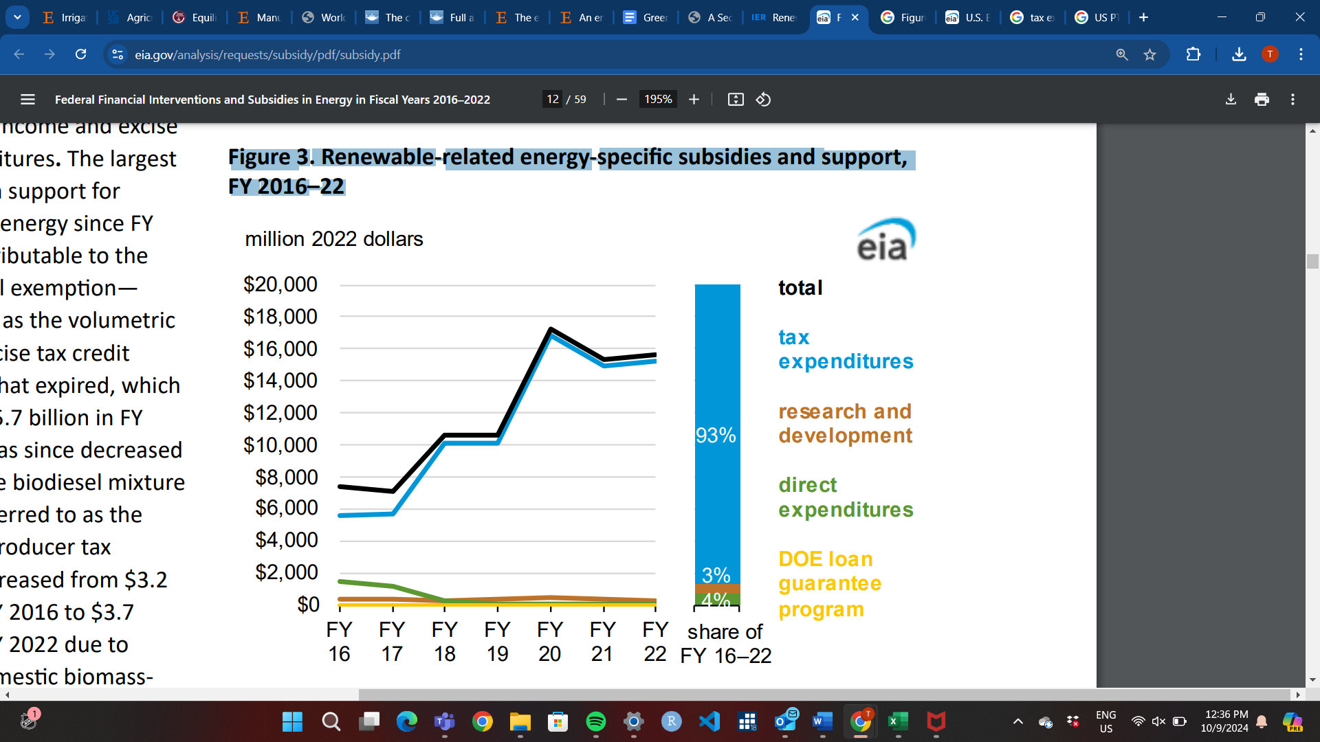

**Figure 1:** Renewable Energy Subsidy Spending in Million 2022 Dollars by Type per Fiscal Year (FY) (*Source: U.S. Energy Information Administration, 2023)*

Subsidies will have an income effect and substitution effect on the economy. The income effect increases purchasing power to facilitate research and development (R&D) for firms already producing green technology, thus spurring innovation, affordability, and efficiency. On the other hand, the substitution effect may disincentivize firms producing close polluting alternatives now facing higher opportunity costs, thus promoting green growth. In general, green technology subsidies are a way to give firms using clean alternatives exhibiting positive externalities an edge over polluters so that the green technology production reaches the socially optimal level.

Lastly, there are environmentally unfriendly subsidies that are typically put in place to develop an industry that is lucrative and profitable, despite the negative repercussions it may have on the environment. In contrast with the previously stated subsidies, environmentally unfriendly subsidies generally have a counterproductive effect on environmental issues and only magnify the negative externality problem that green technology subsidies aim to correct (Rentschler & Bazilian, 2016). These sorts of subsidies are typically found in the fossil fuel industry as subsidizing them may increase the efficiency and affordability of their products. Most of the literature on fossil fuel subsidies on the environment has found a positive correlation (Arzaghi & Squalli, 2023) and even causal effects between fossil fuel subsidies and environmental degradation (Solarin, 2020). The market for fossil fuel energy has high private benefits to both producers and consumers, but even without the subsidies, these markets are overproducing when social costs are taken into consideration. Environmentally unfriendly subsidies are relevant in this paper as subsidies that should be avoided or lowered through reform so that green technology alternatives can fill in their role in production. Since subsidies do not always result in achieving all the intended results, it is always important to analyze the shortcomings of over-subsidization.

**3.2. Subsidy Drawbacks and Over-Subsidization**

Although in general subsidies are good for developing industries, there are also arguments against subsidization of firms. As Bergstrom (2000) argues, subsidies have a positive correlation with growth and productivity, but as the subsidy programs continue, productivity tends to decrease. The theoretical reasoning is that government intervention, such as in the form of subsidies, may inefficiently allocate resources. It is possible that these subsidies are either going to less productive firms, or the subsidy may be taking away the incentive to maximize efficiency, thus resulting in less productive firms (Bergstrom, 2000).

Even if subsidies are maximizing efficiency, this encourages firms to lower the price of their product, which in turn may encourage higher consumption. In many environmental issues in particular, overconsumption is a large issue that tends to increase environmental degradation. As previously discussed, over-subsidization of fossil fuels results in overconsumption of non-renewable energy. The same can be said for higher efficiency in green technology, which may lead to more consumption of energy overall and is preventing the absolute decoupling of technological innovation with environmental degradation. That is, as green technology goes up, environmental degradation is not necessarily going down and this is known as the rebound effect (Vivanco et. al, 2016)

In terms of innovation efficiency, a study in China demonstrates an inverted U-shape relationship between renewable energy R&D subsidy intensity compared to the firm's income (RDS%) and green technology innovation (GTI) (Lin & Xie, 2023) (Figure 2). Therefore, there is an optimal amount of subsidization, and increasing government assistance past this point will actually begin to hurt the industry as it demonstrates diminishing marginal returns on green innovation.

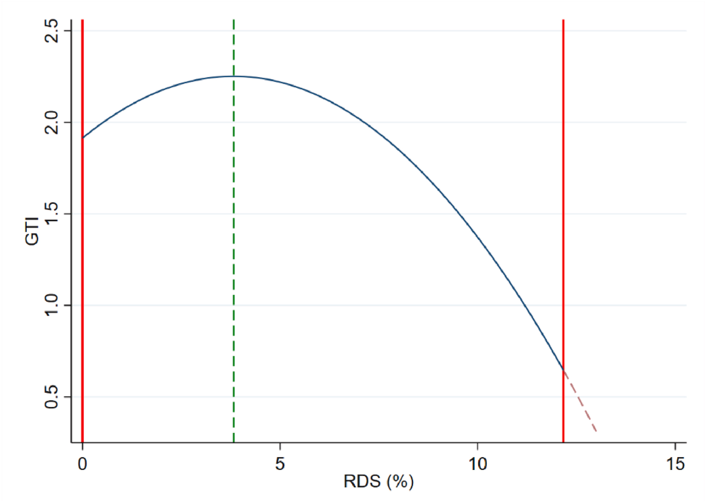

**Figure 2:** Research and Development Subsidy Intensity (RDS%) vs Green Technology Innovation (GTI) **(***Source: Lin & Xie, 2023)*

Similarly, R&D subsidies tend to lead to increasing R&D investments in green technology, but this relationship is also inverted U-shaped because of a crowding-out effect on investment (Lin & Xie, 2023). In other words, as the government spends more on green technology, it will result in less private investments due to higher taxes or interest rates needed to fund the government subsidies. These taxes are known as distortionary taxes and ultimately, this effect may crowd out private investments to the point that it begins to harm the industry. Optimal subsidy intensities may vary in each region, but evidence shows that subsidizing firms too much will have negative effects. Nonetheless, in regulated amounts green technology subsidies can be beneficial to correcting the market failure problems related to the environment and climate change.

**4. Tax and Subsidy Legislation and Policy Analysis**

Having discussed the importance of a carbon tax with examples and economic tax theories, as well as the principles underlying subsidies, in this section we will propose potential carbon tax policies for the United States, which currently lacks a federal carbon tax policy. We will reference previous proposals to guide our policy. Furthermore, we will conduct an in-depth analysis of an existing green subsidy policy, identifying significant loopholes and areas for improvement.

CO2 emissions are one of the most pressing issues related to climate change. As the world’s largest economy, the U.S. accounted for 24.08% of global cumulative CO2 emissions in 2022, the highest share in the world, surpassing the combined emissions of the 27 European Union countries, and China (see Appendix 2). The U.S. emits approximately 5 billion tons of CO2 annually, with a per capita emission rate of 15 tons (Our World in Data, 2022). Given these alarming numbers, it is important to focus on carbon tax policies and green subsidies in the U.S. to adopt green technology.

**4.1. Carbon Tax in the U.S.**

The U.S. is the largest economy of the world that has no federal carbon tax policy, though state and regional carbon cap-and-trade programs exist. For example, the Cap-and-Trade Program in California, Climate Commitment Act in Washington, and the Regional Greenhouse Gas Initiative (RGGI) involving 12 Mid-Atlantic and Northeastern states are notable examples of these efforts. Although several representatives and senators in the U.S. Congress have introduced legislation over the years to establish a carbon tax, at the federal level, a carbon tax policy has yet to be implemented.

**4.1.1. Carbon Tax Policy Recommendations for the U.S.:** This Policy is based on the proposal of Center on Global Energy Policy of Columbia University and previous proposals from U.S. senators and representatives.

* **Tax Rate Structure**:
* Implement a carbon tax starting at $50 per ton of CO2 emissions, with a continuous increase of 2% per ton annually to reflect the growing social cost of carbon and inflation. Appendix 3 shows a $50 per ton carbon tax would decrease emissions by about 40% below the 2005-year levels and by 25% where U.S. is currently on track for in 2030 (Columbia University Center on Global Energy Policy, 2021).
* This gradual increase allows for predictability and stability in the market, encouraging businesses to transition to low-carbon technologies overtime (Columbia University Center on Global Energy Policy, 2021).
* Introduce a carbon border adjustment mechanism that imposes a fee on imports based on their carbon content, aligning with domestic carbon pricing and reducing competitive disadvantages for U.S. businesses (Metcalf, 2019).
* Periodic reviews (every five years) to assess the tax rate against the latest scientific findings on the social cost of carbon, ensuring the tax remains effective and relevant (Columbia University Center on Global Energy Policy, 2021).
* **Coverage and Point of Taxation**:
* Apply the carbon tax to all fossil fuels, including gasoline, natural gas, coal, and diesel, targeting around 75-80% of total U.S. emissions. Appendix 4 demonstrates that the biggest contribution of CO2 emissions is from oil, gas and coal in the U.S.
* Impose the carbon tax upstream, at the point of fossil fuel extraction or importation, which simplifies administration by limiting the number of entities subject to the tax (e.g., oil refineries and natural gas processors). Afterward, the tax could be applied midstream (to electric utilities), and lastly to downstream (households, or vehicles) (Center for Climate and Energy Solutions, 2023).
* Implement specific provisions for emissions-intensive industries at risk of carbon leakage, such as providing temporary rebates or credits to reduce potential economic impacts ( Mideksa, 2024).
* **Revenue Distribution Mechanism**:
* With a $50 carbon tax policy, U.S. can earn $180 billion annually. The impact on U.S. economy will be very low as compared to no carbon tax policy (see Appendix 5) if government use these revenues effectively (Columbia University Center on Global Energy Policy, 2021).
* Allocate a portion of the revenue for investment in green technology, public transit infrastructure, and job training programs to support the transition to a low-carbon economy (Columbia University Center on Global Energy Policy, 2021).
* Redistribute the revenue generated from the carbon tax to American households in the form of dividends, like the Energy Innovation and Carbon Dividend Act, to alleviate the financial burden on low- and middle-income families (U.S. Congress, 2019).
* Partnerships with local governments to support initiatives that mitigate the impact of the carbon tax on vulnerable populations (U.S. Congress, 2019).
* **Regulatory Framework**:
* Establish a clear timeline for the carbon tax, including a starting date and gradual increases, along with a transparent reporting system (TRS) to track emissions reductions using data from the Environmental Protection Agency (EPA) (U.S. Congress, 2019).
* Mandate regular compliance reporting from affected companies, using the EPA to monitor emissions and ensure accountability in reporting (Calcaterra et al., 2024).
* **Evaluation and Adjustment Process**:
* Conduct regular assessments of the impact of carbon tax on emissions reduction and economic performance. Create a publicly accessible database to track these metrics, allowing for transparency and ongoing evaluation of the effectiveness of policy (Zhang et al., 2016).
* Allow for policy adjustments based on evaluation outcomes, enabling flexibility in response to unforeseen challenges or shifts in the economic cycle (Fremstad & Paul 2019).

Implementing a carbon tax in the U.S. following the above recommendations can significantly reduce greenhouse gas emissions while promoting economic growth through innovation in green technology. This policy emphasizes a structured approach that includes robust mechanisms for implementation, monitoring, and revenue distribution. Although prioritizing systematic and transparent methods will maximize the political feasibility of a carbon tax, subsidies in the U.S. continue to maintain the most bipartisan support in implementing green technology.

**4.2. Green Subsidy in the U.S.**

In this section we will dive into a specific subsidy program to explore it in depth. In particular, we will highlight how a policy has succeeded in its goals and how it may have come short in other areas. For subsidies in the United States, the Renewable Energy Production Tax Credit (PTC) is an excellent example of an indirect subsidy. The PTC was first created by the Energy Policy Act of 1992 as a 1.5 cent per kilowatt hour (kWh) tax credit in 1992 U.S. dollars that mainly focuses on wind power. Today, as long as the plant begins construction before the expiration date of the PTC, the energy producer will receive the indirect subsidy for the first 10 years of its production with the tax credit value adjusted every year (EIA, 2012). Since 1992 the PTC has been renewed 13 times, with the most recent being by the Inflation Reduction Act of 2022 setting the 2024 dollar amount to 2.6 cents/kWh and extending the program until the end of 2024 (Wind Exchange, 2024).

**4.2.1. Successful Outcomes of the U.S. PTC**

The most successful outcome of the U.S. PTC is a real attempt passed at the federal level to correct the carbon market failure. Carbon taxes may be more effective, but subsidy programs encouraging the production of goods are always preferred. The PTC is meant to grow and develop the wind industry using tax credits that will lower the costs of the firms. Wind producers will then be able to buy more infrastructure and invest in innovation or other forms of expanding production. Moreover, these lower costs and potential to grow should attract more outside investment into wind energy, further developing the industry (Sherlock, 2020).

Although it is difficult to isolate the effects of the PTC, the wind industry has come a long way since the policy was first passed into legislation. In 1991, right before the Energy Policy Act created the PTC, the US generated 2.7 billion kWh (2.7 Terawatt hours) of wind electricity, which was enough to power Washington DC and San Francisco combined, making it a world record even at the time (Gipe, 1993). Using data from the EIA from March 2024, the US is now producing around 45.9 billion kWh (45.9 Terawatts hours) (EIA, 2024). Energy production today is 17 times larger than in 1991, but it has also grown tremendously compared to coal power plant production (Figure 3).

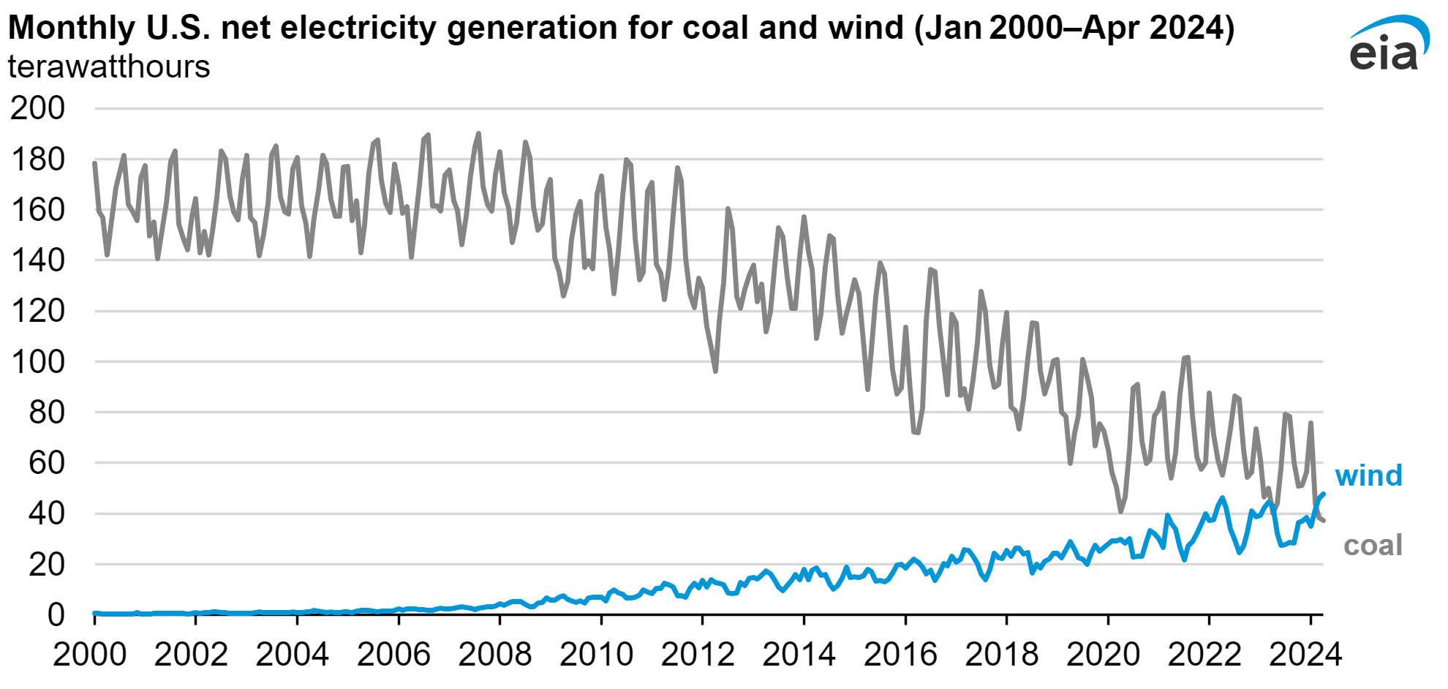

**Figure 3:** Monthly U.S. net electricity generation for coal and wind (Jan 2000-Apr 2024) - Terawatt hours (*Source: EIA, 2024)*

As discussed in section 3, subsidies can have an income and a substitution effect. Again, it is not possible to say the PTC caused the increase in wind as well as the decrease in coal, but it is very likely that the subsidies income effect allowed wind energy firms to increase their production over the years. On the other hand, it is possible that the substitution effect of the subsidy reallocated private investments previously in polluting alternatives such as coal, into new wind energy projects that were seen to have more future potential.

**4.2.2. Failures of the U.S. PTC**

Although the U.S. renewable energy PTC has certainly helped grow the wind power industry, there are many critiques to its shortcomings and where it may be able to improve. Some of the opposition is based on the typical subsidy drawbacks that were mentioned in section two. For example, the incentive from these indirect subsidies are not necessarily felt evenly among all producers and the subsidy may be allowing producers with more costly alternatives to succeed. This leads to a misallocation of resources and inefficiency that is typically associated with government intervention in the case of market failures. The PTC also exhibits a rebound effect, where energy becomes cheaper, but the consumption of renewable energy in certain sectors also increases (Sherlock, 2020). A third drawback to the subsidy is that it will decrease tax revenue to the government, meaning the government may cut funding to other programs, or raise a distortionary tax that Metcalf (2007) argues will hurt economic efficiency. This goes along with Lin and Xie’s (2023) findings from section 3 that subsidies may crowd out investment if they are too high, leading to negative impacts on renewable energy industry growth.

Lastly, one of the main failures specific to the U.S. PTC, is its frequent, but short term renewments. Ever since its creation in 1992, the PTC has either briefly expired or come close to expiring before being renewed. Then, when it is renewed, it is usually for only one to two years. This delay to renew and the short term extensions are very costly to the growth of wind energy. If there is uncertainty regarding the renewal of the PTC, investors wait before entering the industry. Then when the PTC eventually does get renewed, there is a “ramp-up” phase that may take 8-12 months before firms even start producing (Barradale, 2010).

**Figure 4:** PTC Legislative Acts and Its Effects on Industry Growth*(Source: Barradale, 2010)*

The top part of Figure 4 illustrates the various legislative acts throughout 1992-2009 that renewed the PTC. The small black arrows indicate when the new act was enacted and sometimes, they were made ahead of time to ensure there was no uncertainty about the continuation of the subsidy. However, there were also many instances where there was a policy lapse with a brief period of no PTC. This led to long ramp up phases before new wind energy plants started coming online, resulting in very low wind capacity additions for those years which is reflected in the lower half of figure 4. Even though it has been shown that longer PTC terms would be beneficial to domestic wind turbine growth as well as lead to lower costs due to more efficient use of capital (Wiser et al., 2007), Barradale (2010) admits this can be challenging since policy makers tend to avoid having large spending programs associated to their name.

**4.3. Future Forward Policy Proposal**

Although there have been many good bipartisan proposals in the U.S., some of the only policies that have passed have been subsidy initiatives. Subsidies can be effective in promoting innovation and implementation of green technology, however, there are many flaws that diminish its overall efficiency. To have appropriate legislation regarding the carbon market failure, a carbon tax is absolutely necessary. A Pigouvian carbon tax based on the social cost of carbon is the most efficient way to account for the negative externality carbon has on health and climate change. Going forward, a combination of subsidies and taxes will be necessary. First, since taxes are generally unfavorable, all fossil fuel subsidies should be eliminated along with the continuation of current PTC or other green subsidy programs. Then, as previously discussed in the carbon tax policy recommendation, a low carbon tax should be implemented starting at $50 per ton that can increase gradually, providing the economic signals necessary to shift industries and consumers toward greener alternatives and encourage investment in green technology. As distortionary taxes are lowered and income from the carbon tax is redistributed into social programs, the feasibility of a carbon tax may be more evident. With time, the carbon tax can be increased until it reaches a more accurate SCC and, in the meantime, subsidies will play the role of a temporary transition from no carbon tax to an accurate one equal to the SCC.

**5. Conclusion**

The essay highlights the important need for the U.S. to implement a robust policy framework to reduce carbon emissions and promote green technology innovation, particularly through the introduction of a federal carbon tax. We begin by outlining the general economic theories behind taxes and subsidies as well as their drawbacks. Next, we dive into specific proposals or policies to analyze what works and what does not. In the end we conclude that a balanced approach that combines well-structured carbon taxes with targeted subsidies is the most effective strategy for promoting green technologies. The U.S. is greatly positioned to lead this transformation, implementing policies that not only reduce emissions but also stimulate green technology innovation. This simultaneous focus on technological innovation and environmental protection is crucial both locally and globally to establish a sustainable future for all.

**References**

Acemoglu, D., Aghion, P., Bursztyn, L., & Hemous, D. (2012). The environment and directed technical change. *American Economic Review*, 102(1), 131-166. <https://doi.org/10.1257/aer.102.1.131>

Adão, B., Narajabad, B., & Temzelides, T. (2024). Renewable technology adoption costs and economic growth. *Energy Economics, 129,* 107255. <https://doi.org/10.1016/j.eneco.2023.107255>

Aldy, J. E., & Stavins, R. N. (2012). The promise and problems of pricing carbon: Theory and experience. *Journal of Environmental Economics and Management*, 66(3), 380–397.

Arzaghi, M., & Squalli, J. (2023). The environmental impact of fossil fuel subsidy policies. *Energy Economics*, *126*, 106980-. https://doi.org/10.1016/j.eneco.2023.106980

Barman, P., Dutta, L., Bordoloi, S., Kalita, A., Buragohain, P., Bharali, S., & Azzopardi, B. (2023). Renewable energy integration with electric vehicle technology: A review of the existing smart charging approaches. *Renewable and Sustainable Energy Reviews, 183*, 113518. <https://doi.org/10.1016/j.rser.2023.113518>

Barradale, M. J. (2010). Impact of public policy uncertainty on renewable energy investment: Wind power and the production tax credit. *Energy Policy*, *38*(12), 7698–7709. <https://doi.org/10.1016/j.enpol.2010.08.021>

Bergstrom, F. (2000). Capital Subsidies and the Performance of Firms. *Small Business Economics*, *14*(3), 183–193. <https://doi.org/10.1023/A:1008133217594>

Bernard, J.-T., & Kichian, M. (2019). The long and short run effects of British Columbia's carbon tax on diesel demand. *Energy Policy, 131*, 380-389. <https://doi.org/10.1016/j.enpol.2019.04.021>

Calcaterra, M., Emmerling, J., & Granella, F. (2024). Climate change impacts on the within-country income distributions. *Journal of Environmental Economics and Management, 127,* 103012. <https://doi.org/10.1016/j.jeem.2024.103012>

California Air Resources Board. (2013). Cap-and-trade program. Retrieved October 21, 2024, from <https://ww2.arb.ca.gov/our-work/programs/cap-and-trade-program>

Cannan, E. (1921). Review of *The economics of welfare*, by A. C. Pigou. *The Economic Journal, 31*(122), 206–213. <https://doi.org/10.2307/2222816>

Cao, J., Ho, M., & Jorgenson, D. (2009). The local and global benefits of green tax policies in China. Review of Environmental Economics and Policy, 3, 189-208.

Center for Climate and Energy Solutions. (2003). Carbon tax basics. Retrieved October 21, 2024, from <https://www.c2es.org/content/carbon-tax-basics/>

Coase, R. H. (1960). The problem of social cost. *Journal of Law and Economics, 3*, 1-44. <https://www.jstor.org/stable/724810>

Columbia University Center on Global Energy Policy. (2021). What you need to know about a federal carbon tax in the United States. Retrieved October 21, 2024, from <https://www.energypolicy.columbia.edu/publications/what-you-need-to-know-about-a-federal-carbon-tax-in-the-united-states/>

Convery, F., & Redmond, L. (2007). Market and price developments in the european union emissions trading scheme. Review of Environmental Economics and Policy, 1, 66-87.

Dechezleprêtre, A., Nachtigall, D., & Venmans, F. (2023). The joint impact of the European Union emissions trading system on carbon emissions and economic performance. *Journal of Environmental Economics and Management, 118*, 102758. <https://doi.org/10.1016/j.jeem.2022.102758>

Fischer, C. (2016). Strategic Subsidies for Green Goods. *Resources for the Future Discussion Paper, 16-12*. https://papers.ssrn.com/sol3/papers.cfm?abstract_id=2789809

Fischer, C., Greaker, M., & Rosendahl, K. E. (2017). Robust technology policy against emission leakage: The case of upstream subsidies. *Journal of Environmental Economics and Management, 84*, 44–61. <https://doi.org/10.1016/j.jeem.2017.02.001>

Fischer, C., & Springborn, M. (2011). Emissions targets and the real business cycle: Intensity targets versus caps or taxes. *Journal of Environmental Economics and Management*, 62(3), 352–366.

Fremstad, A., & Paul, M. (2019). The impact of a carbon tax on inequality. *Ecological Economics*, *163*, 88-97. <https://doi.org/10.1016/j.ecolecon.2019.04.016>

*Germany's Energiewende*. (2021, May 27). World Nuclear Association. Retrieved October 28, 2024, from <https://world-nuclear.org/information-library/energy-and-the-environment/energiewende>

Gilli, M., Calcaterra, M., Emmerling, J., & Granella, F. (2024). Climate change impacts on the within-country income distributions. *Journal of Environmental Economics and Management, 127,* 103012. <https://doi.org/10.1016/j.jeem.2024.103012>

Gipe, P. (1993). 1992 status report: U.S. sets new wind energy record as domestic market stagnates: Renewable energy: technology and the environment. *Renewable Energy*, *3*(2–3), 121–125.

Goulder, L.H. (1995). Environmental taxation and the double dividend: A reader’s guide. *International Tax and Public Finance, 2*(2), 157-183.

Grossman, G.M., & Krueger, A.B. (1995). Economic growth and the environment. *The Quarterly Journal of Economics, 110*(2), 353-377.

Hardin, G. (1968). The tragedy of the commons. *Science, 162*(3859), 1243-1248.

Hellegers, P., Davidson, B., Russ, J., & Waalewijn, P. (2022). Irrigation subsidies and their externalities. *Agricultural Water Management*, *260*. <https://doi.org/10.1016/j.agwat.2021.107284>

Hinderks, W. J., & Wagner, A. (2019). Pricing German Energiewende products: Intraday cap/floor futures. *Energy Economics, 81*, 287-296. <https://doi.org/10.1016/j.eneco.2019.04.005>

Hoel, M. (1996). Should a carbon tax be differentiated across sectors? *Journal of Public Economics*, *59*(1), 17-32. <https://doi.org/10.1016/0047-2727(94)01490-6>

Jotzo, F., & Pezzey, J.C.V. (2007). Optimal intensity targets for emissions trading under uncertainty, *Environmental and Resource Economics*, 83, 280–286

Kumbhakar, S. C., Badunenko, O., & Willox, M. (2022). Do carbon taxes affect economic and environmental efficiency? The case of British Columbia’s manufacturing plants. *Energy Economics, 115*, 106359. <https://doi.org/10.1016/j.eneco.2022.106359>

Lin, B., & Xie, Y. (2023). Positive or negative? R&D subsidies and green technology innovation: Evidence from China’s renewable energy industry. *Renewable Energy*, *213*, 148–156. <https://doi.org/10.1016/j.renene.2023.06.011>

Liu, D., Qi, S., & Xu, T. (2023). In the post-subsidy era: How to encourage mere consumers to become prosumers when subsidies are reduced? *Energy Policy, 174,* 113451.<https://doi.org/10.1016/j.enpol.2023.113451>

Lu, T., Li, X., Lin, J.-H., Chang, C.-H., & Cai, Z. (2024). Assessing the impact of climate policies on equity risk under sustainable insurance: Cap-and-trade regulation, energy-saving technology subsidies, and carbon tariffs. *Energy Economics, 139*, 107902. <https://doi.org/10.1016/j.eneco.2024.107902>

Marron, Donald B., & Eric J. Toder. (2014). Tax Policy Issues in Designing a Carbon Tax. *American Economic Review*, 104 (5): 563–68**.**

Metcalf, G. E. (2006). *Federal Tax Policy Towards Energy*. National Bureau of Economic Research.

Metcalf, G. E. (2019). On the economics of a carbon tax for the United States. *Brookings Papers on Economic Activity*, *Spring*, 405-484. <https://doi.org/10.1353/eca.2019.0005>

Metcalf, G. E., & Weisbach, D. (2009). The design of a carbon tax. *Harvard Environmental Law Review*, 33(2), 499–556

Mideksa, T. K. (2024). Pricing for a cooler planet: An empirical analysis of the effect of taxing carbon. *Journal of Environmental Economics and Management, 127,* 103034. <https://doi.org/10.1016/j.jeem.2024.103034>

Murray, B., & Rivers, N. (2015). British Columbia’s revenue-neutral carbon tax: A review of the latest “grand experiment” in environmental policy. *Energy Policy, 86*, 674-683. <https://doi.org/10.1016/j.enpol.2015.08.011>

Nordhaus, W.D. (1993) Optimal Greenhouse-Gas Reductions and Tax Policy in the Dice Model. The American Economic Review, 83, 313-317.

Nordhaus, W. D. (2007). A review of the Stern review on the economics of climate change. *Journal of Economic Literature*, 45(3), 686-702. <https://doi.org/10.1257/jel.45.3.686>

Organisation for Economic Co-operation and Development. (1972). *Guiding principles concerning international economic aspects of environmental policies*. OECD.

Our World in Data. (2022.). CO₂ emissions by country: United States. Retrieved October 21, 2024, from <https://ourworldindata.org/co2/country/united-states>

Parry, I. W. H. (1998). A Second-Best Analysis of Environmental Subsidies. *International Tax and Public Finance*, *5*(2), 153-170. <https://doi.org/10.1023/A:1008638320593>

Pigou, A. C. (1920). *The economics of welfare*. Macmillan & Co.

Pindyck, R. S. (2019). The social cost of carbon revisited.*Journal of Environmental Economics and Management, 94*, 140. <https://doi.org/10.1016/j.jeem.2019.02.003>

Regional Greenhouse Gas Initiative. (2005). Home. Retrieved October 21, 2024, from <https://www.rggi.org/>

Rennert, K., Prest, B. C., Pizer, W., Newell, R. G., Anthoff, D., Kingdon, C., Rennels, L., Cooke, R., Raftery, A. E., Ševčíková, H., & Errickson, F. (2021). *The social cost of carbon: Advances in long-term probabilistic projections of population, GDP, emissions, and discount rates* (RFF Working Paper Series 21-28). Resources for the Future.

Rentschler, J., & Bazilian, M. (2017). Reforming fossil fuel subsidies: drivers, barriers and the state of progress. *Climate Policy*, *17*(7), 891–914. <https://doi.org/10.1080/14693062.2016.1169393>

Sherlock, M. F. (2020). *The Renewable Electricity Production Tax Credit: In Brief*. crsreports.congress.gov. <https://sgp.fas.org/crs/misc/R43453.pdf>

Solarin, S. A. (2020). An environmental impact assessment of fossil fuel subsidies in emerging and developing economies. *Environmental Impact Assessment Review*, *85*, 106443–106449. <https://doi.org/10.1016/j.eiar.2020.106443>

U.S. Congress. (2019). H.R.763 - Energy Innovation and Carbon Dividend Act of 2019. Retrieved October 21, 2024, from <https://www.congress.gov/bill/116th-congress/house-bill/763>

U.S. Congress. (2020). S.4484 - A bill to require the Secretary of Energy to establish a carbon capture technology program. Retrieved October 21, 2024, from <https://www.congress.gov/bill/116th-congress/senate-bill/4484>

U.S. Congress. (2019). S.2284 - A bill to promote the development of carbon capture, utilization, and storage technologies, and for other purposes. Retrieved October 21, 2024, from <https://www.congress.gov/bill/116th-congress/senate-bill/2284/text>

U.S. Energy Information Administration. (2012, November 21). *Wind energy tax credit set to expire at the end of 2012*. eia.gov. <https://www.eia.gov/todayinenergy/detail.php?id=8870>

U.S. Energy Information Administration. (2023, August). *Federal Financial Interventions and Subsidies in Energy in Fiscal Years 2016-2022*. eia.gov. <https://www.eia.gov/analysis/requests/subsidy/pdf/subsidy.pdf>

U.S. Energy Information Administration. (2024, August 13). *U.S. wind generation hit record in April 2024, exceeding coal-fired generation*. eia.gov. <https://www.eia.gov/todayinenergy/detail.php?id=62784#:~:text=Installed%20wind%20power%20generating%20capacity,150.1%20GW%20in%20April%202024>.

Vivanco, D. F., Kemp, R., & van der Voet, E. (2016). How to deal with the rebound effect? A policy-oriented approach. *Energy Policy*, *94*, 114–125. <https://doi.org/10.1016/j.enpol.2016.03.054>

Washington State Department of Ecology. (2021). Climate Commitment Act. Retrieved October 21, 2024, from <https://ecology.wa.gov/air-climate/climate-commitment-act>

Wind Exchange. (2024). *Production Tax Credit and Investment Tax Credit for Wind Energy*. Energy.gov. <https://windexchange.energy.gov/projects/tax-credits>.

Wiser, R., Bolinger, M., & Barbose, G. (2007). Using the Federal Production Tax Credit to Build a Durable Market for Wind Power in the United States. *The Electricity Journal*, *20*(9), 77–88. <https://doi.org/10.1016/j.tej.2007.10.002>

Xu, B., & Lin, B. (2024). Green finance, green technology innovation, and wind power development in China: Evidence from spatial quantile model. *Energy Economics, 132*, 107463. <https://doi.org/10.1016/j.eneco.2024.107463>

Zhang, K., Wang, Q., Liang, Q.-M., & Chen, H. (2016). A bibliometric analysis of research on carbon tax from 1989 to 2014. *Renewable and Sustainable Energy Reviews*, *58*, 297-310. <https://doi.org/10.1016/j.rser.2015.12.089>

**Appendix 1:** Policy Comparison*(Source: Our World in Data)*

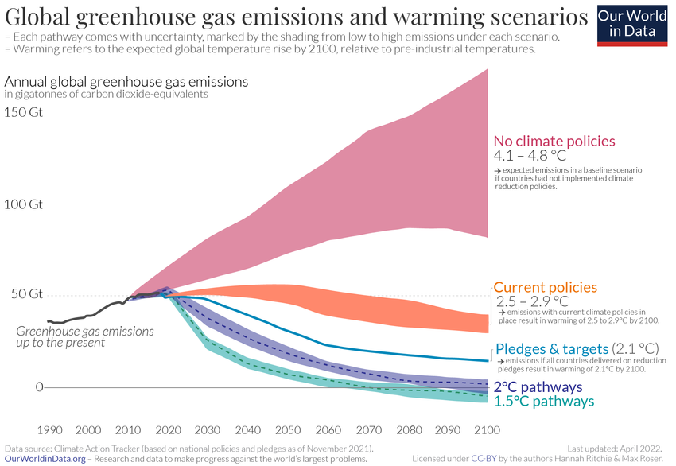

**Appendix 2**: Share of cumulative CO2 emissions, 2022 *(Source: Our World in Data)*

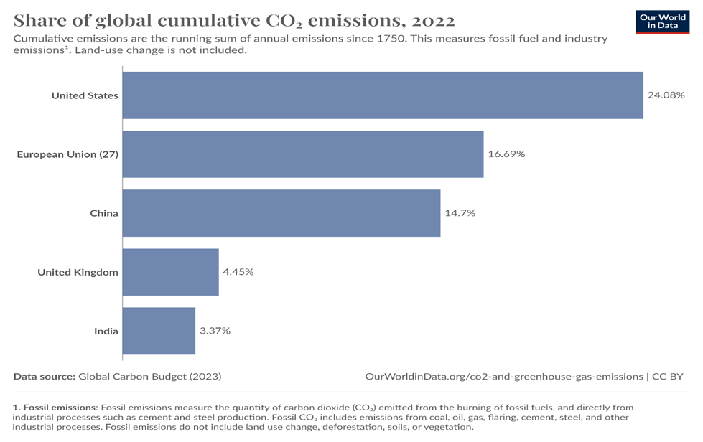

**Appendix 3:** Emission Impact *(Source: Center on Global Energy Policy)*

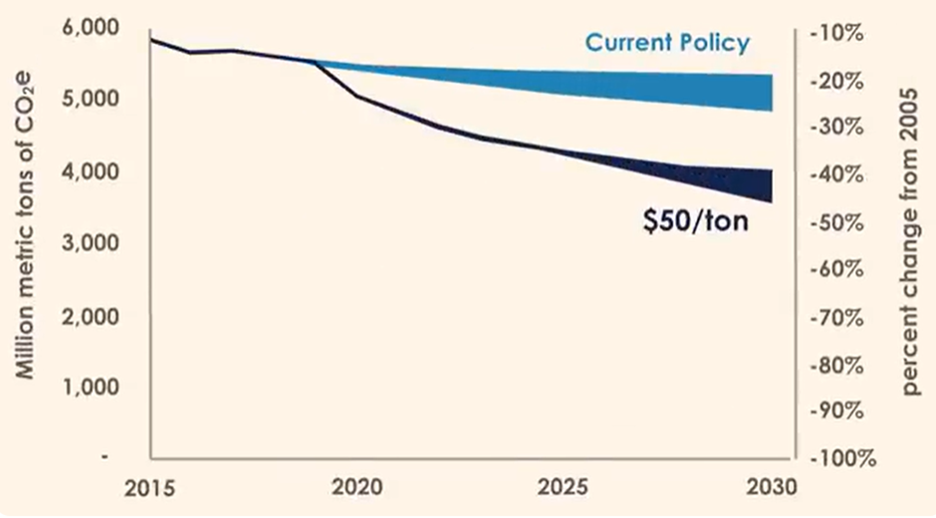

**Appendix 4:** CO₂ emissions by fuel or industry in U.S. *(Source: Our World in Data)*

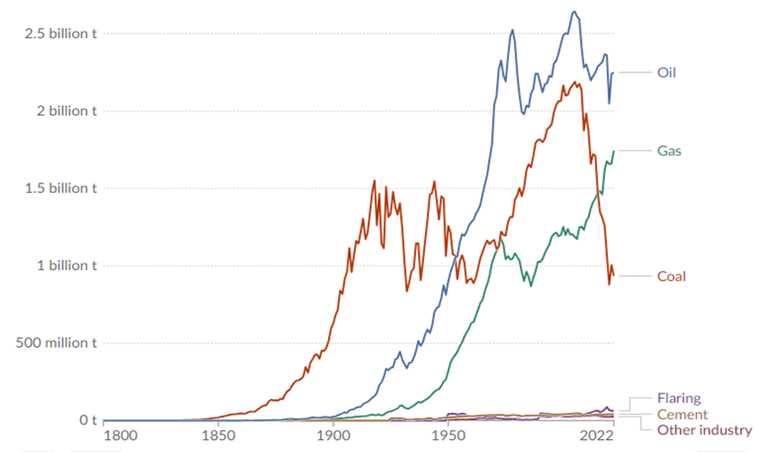

**Appendix 5:** Impact on Economy *(Source: Center on Global Energy Policy)*

